EGE UNIVERSITY
LOGIC DESIGN LABORATORY
EXPERIMENT-2
Basic Logic Functions
PRELIMINARY WORK

- Show the equivalence of the following functions and draw their logic diagrams.

  - (x+y)’=x’y’ by truth table.
  - dual of (a) by truth table.
  - (xy)’ + x’y + xy = 1 by algebraic manipulation.
  - 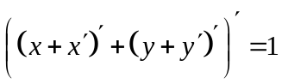 by algebraic manipulation.
  - 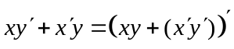 by algebraic manipulation.
- Obtain the truth tables for the following functions and draw their logic diagrams.
  - x’y +xz’
  - xy’+zt’

EXPERIMENTAL WORK
Connect all circuits.
DISCUSSION
Compare theoretical results and experimental results.

